**Research for the logo**

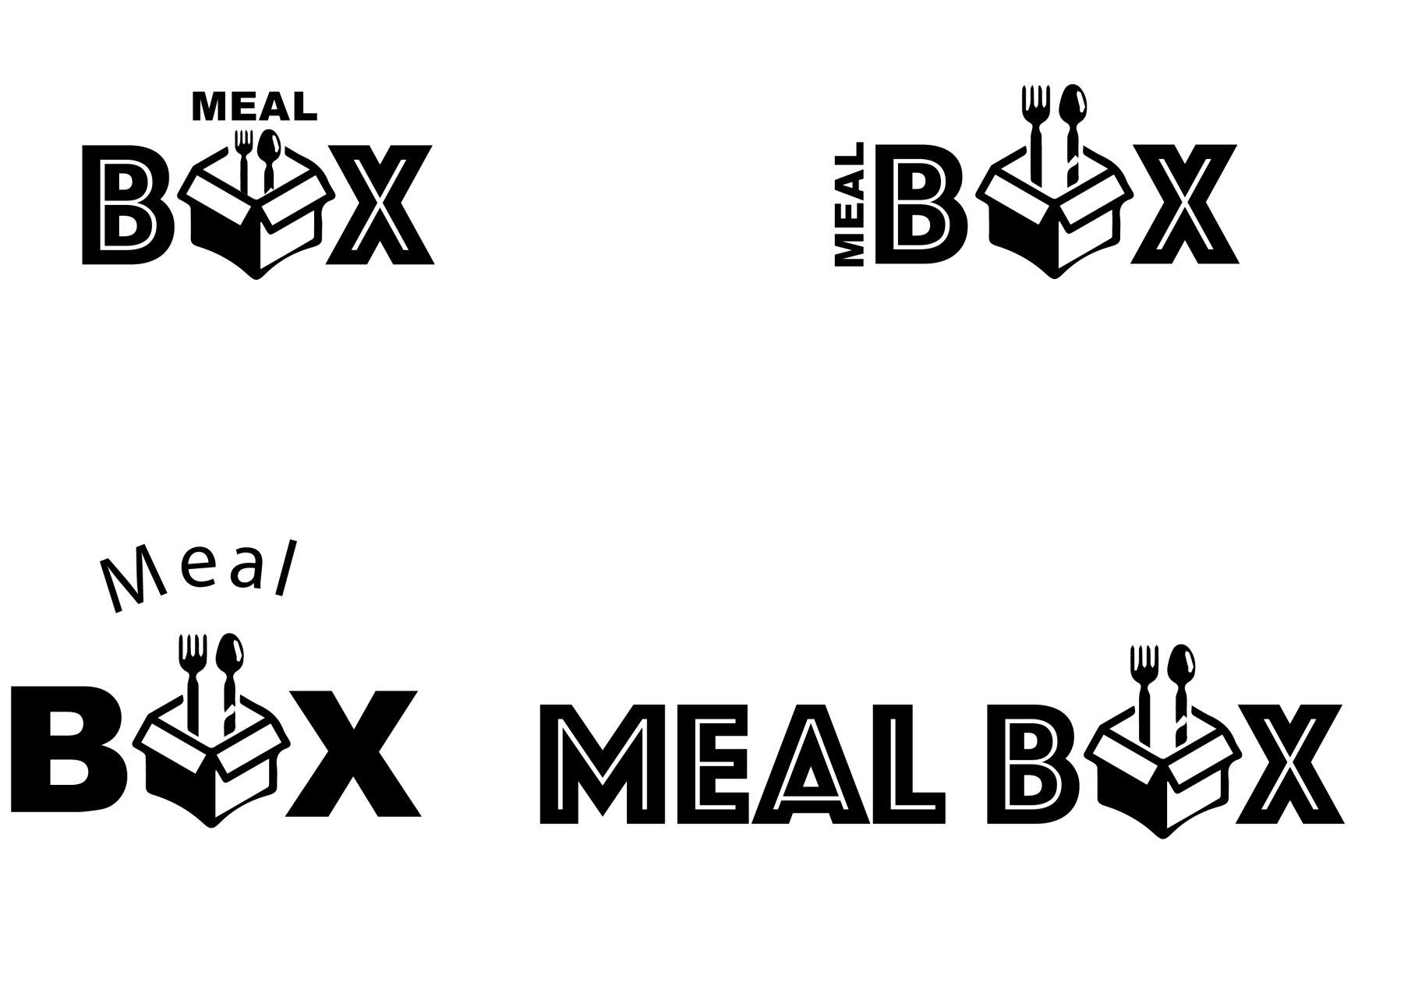

**Logos for MealBox**

**Why change: The name and the image of a box didn’t reflect what we are doing, it suggested a delivery app, also the emphasis is more in the word box then in the word meal.**







**Logos for MealBox with an Icon as a logo**

**Why change: Firstly the idea was to have a logo that explains more about the app, this logo reflects the concept of international food, however the logo itself wouldn’t be enough for people to associate the logo with our name as we are not globally known.**

**Studies of new name and logo**

Why change: The current name (MealBox) wasn’t making sense anymore because the name wasn’t reflecting what we are doing ,also the word box is a contradiction in terms of shape (rounded and squared) with the new logo which was changed for the globe on the plate as shown above.

The new name chosen is MealCrew, it express the sense of people doing things together, the sense of community and common interest.

Dictionary.com defines crew as “ a group of people involved in a particular kind of work or working together”

The logos below are the studies with the current name Mealcrew

